DevNotes
A production-ready full-stack notes application deployed on Kubernetes with automated CI/CD, persistent storage, and caching.
DevNotes Main Dashboard

Architecture
+-------------+ +-------------+ +-------------+
| Browser |---->| Nginx |---->| React UI |
+-------------+ +-------------+ +-------------+
|
v
+-------------+
| Node.js |
| Backend |
+-------------+
|
+------------+------------+
v v
+-------------+ +-------------+
| PostgreSQL | | Redis |
| (PVC) | | (Cache) |
+-------------+ +-------------+

Tech Stack
Layer | Technology
Frontend | React, Vite, Nginx
Backend | Node.js, Express
Database | PostgreSQL 15
Cache | Redis 7
Orchestration | Kubernetes
CI/CD | GitHub Actions
Registry | Docker Hub

Features
- Create, edit, delete notes with tags
- Pin important notes
- Search and filter by tags
- Persistent storage (survives pod restarts)
- Redis caching for performance
- Automated CI/CD with versioned Docker images
- Health checks and graceful error handling

Screenshots

Main Dashboard
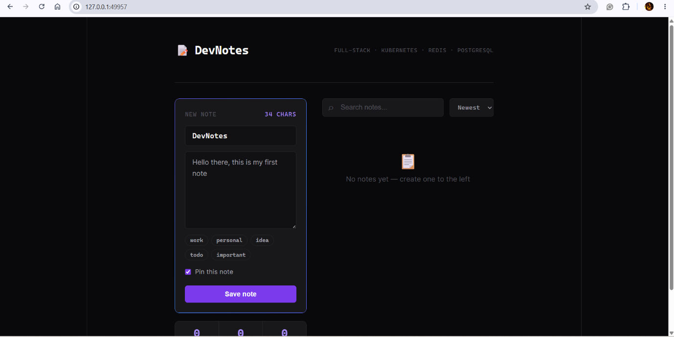

Creating a Note


Note Saved Successfully
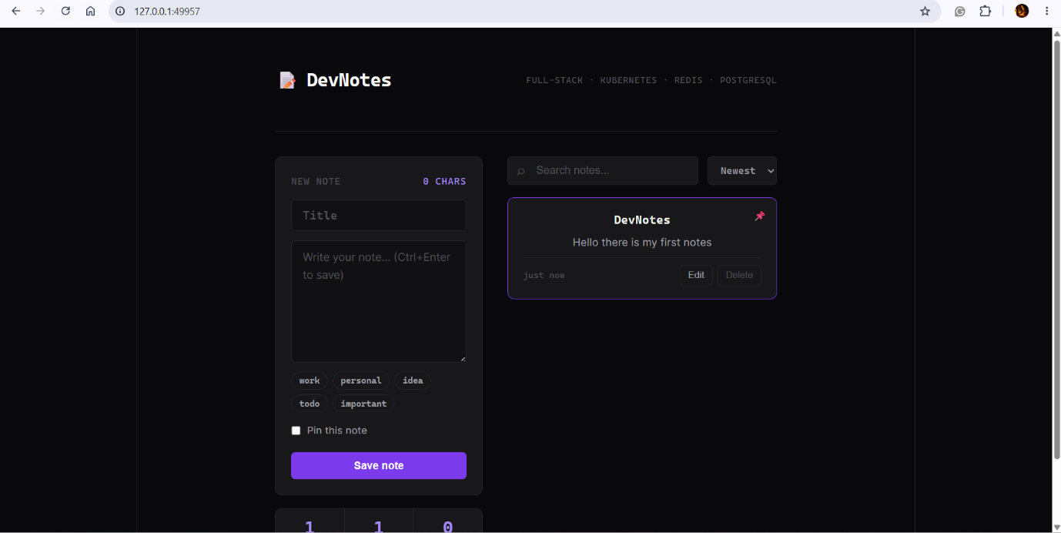
CI/CD Pipeline
Every push to main triggers:
- Build & Push Backend -> vineethgongati/devnotes-backend:v{N}
- Build & Push Frontend -> vineethgongati/devnotes-frontend:v{N}
- Update K8s Manifests -> Auto-commit image tags to repo

Quick Start (Local)
# Clone
git clone https://github.com/VineethGongati/devnotes.git
cd devnotes
# Start with Docker Compose
docker-compose up
# Or deploy to Kubernetes
kubectl apply -f k8s/

Key Design Decisions

Why PVC over StatefulSet?
For a single PostgreSQL instance, a Deployment + PVC is simpler and sufficient. StatefulSet would be needed for a primary-replica setup.

Why Nginx reverse proxy?
Eliminates hardcoded backend URLs in the frontend. The browser calls /api/notes and Nginx routes it to the backend service internally.

Why versioned tags instead of :latest?
:latest causes cache issues and makes rollbacks impossible. Versioned tags (v1, v2) enable traceability and easy rollbacks.

Lessons Learned
- K8s DNS: Service names must match exactly (devnotes-postgres != postgres-service)
- imagePullPolicy: Never prevents CI/CD from working – remove it
- GitHub Actions needs Read and write permissions to auto-commit manifest updates

Connect
- LinkedIn: www.linkedin.com/in/vineeth-gongati-b57248210
Open to: Cloud Engineer | DevOps | SRE roles

